**Introduction**

**Morphology:**

Morphology is a broad set of image processing operations that process images based on shapes. Morphological operations apply a structuring element to an input image, creating an output image of the same size. In a morphological operation, the value of each pixel in the output image is based on a comparison of the corresponding pixel in the input image with its neighbours. By choosing the size and shape of the neighbourhood, you can construct a morphological operation that is sensitive to specific shapes in the input image. Morphological operationsaffect the shapes of objects and regionsin binary images.

There are 5 types of morphological operations. They are

1. Dilation
2. Erosion
3. Median
4. Open
5. Close

**Implementation:**

**DILATION:**

Dilation is one of the most basic morphological operations. The dilation operator takes two pieces of data as inputs. The first is the binary image(B) which is to be dilated. The second is a set of coordinate points known as a [structuring element](https://homepages.inf.ed.ac.uk/rbf/HIPR2/strctel.htm)(S). It is this structuring element that determines the precise effect of the dilation on the input image. Move S over B placing origin at each pixel. Considering only the 1-pixel locations in S, compute the binary ‘OR’ of corresponding elements in B. The value of the output pixel is the maximum value of all the pixels in the input pixel's neighbourhood. In a binary image, if any of the pixels is set to 1, the output pixel is set to 1.  Dilation adds pixels to the boundaries of objects in an image. The number of pixels added from the objects in an image depends on the size and shape of the structuring element used to process the image. Dilation removes object holes of too small size and also removes gaps of which are too narrow.

We move the structuring element(cross or square or hybrid) on the image. We are taking each pixel of the structuring element and comparing it with the threshold. If the pixel value is greater than threshold, then we make the center pixel equal to the maximum intensity of the area of the structuring element.

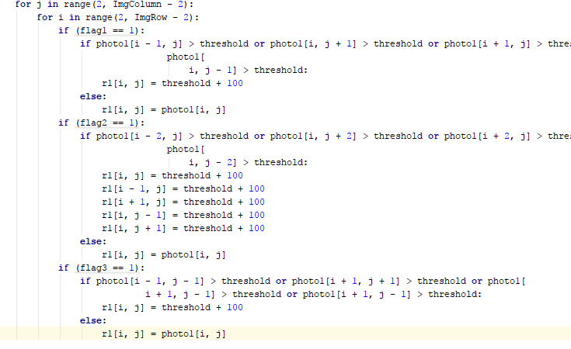

**EROSION:**

Erosion is one of the most basic morphological operations. The erosion operator takes two pieces of data as inputs. The first is the binary image(B) which is to be eroded. The second is a set of coordinate points known as a [structuring element](https://homepages.inf.ed.ac.uk/rbf/HIPR2/strctel.htm)(S). Move S over B placing origin at each pixel. Considering only the 1-pixel locations in S, compute the binary ‘AND’ of corresponding elements in B. The value of the output pixel is the minimum value of all the pixels in the input pixel's neighbourhood. In a binary image, if any of the pixels is set to 0, the output pixel is set to 0. Erosion removes pixels on object boundaries. The number of pixels removed from the objects in an image depends on the size and shape of the structuring elementused to process the image. Erosion removes objects of too small size and removes peninsulas which are too narrow.

We move the structuring element(cross or square or hybrid) on the image. We are taking each pixel of the structuring element and comparing it with the threshold. If the pixel value is lesser than threshold, then we make the center pixel equal to the minimum intensity of the area of the structuring element.

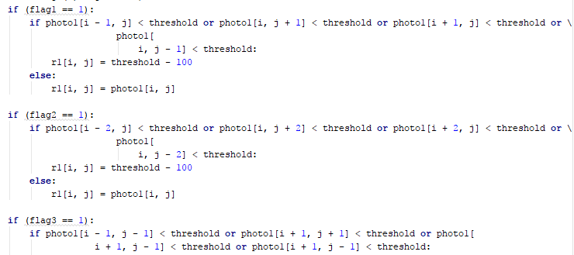

**MEDIAN:**

Median possesses qualitative attributes of both dilation and erosion. The value of the output pixel is the majorityvalue of all the pixels in the input pixel's neighbourhood. Median morphological operation does not generally change the size of objects or background. Median is its own dual, since MEDIAN [NOT(I)] = NOT [MEDIAN(I)]. Thus, the median is a shape smoother. It is a filter. Median removes both objects and holes of too-small size, as well as both gaps and peninsulas which are too narrow.

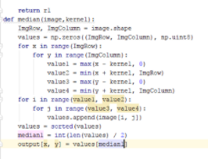

**OPEN:**

OPEN morphological operation is derived from the fundamental operations of erosion and dilation. Opening is defined as an erosion followed by a dilation using the same structuring element for both operations. Given an image B and structuring element S, define OPEN(B, S) = DILATE [ERODE(B, S), S]. OPEN operation removes too-small objects, but not holes or gaps. It does not affect the size of the object.



**CLOSE:**

CLOSE morphological operation is derived from the fundamental operations of erosion and dilation. Closing is opening performed in reverse. It is defined simply as a dilation followed by an erosion using the same structuring element for both operations. Given an image B and structuring element S, define CLOSE(B,S) = ERODE [DILATE(B,S),S]. CLOSE operation removes too-small holes/gaps but not objects or peninsulas. It does not affect the size of the object.



**STRUCTURING ELEMENT:**

Structuring element is defined as a shape which is used to interact with a given image, with the purpose of drawing conclusions on how this shape fits or misses the shapes in the image. It is typically used in morphological operations, such as [dilation](https://en.wikipedia.org/wiki/Dilation_(morphology)), [erosion](https://en.wikipedia.org/wiki/Erosion_(morphology)), median, [opening](https://en.wikipedia.org/wiki/Opening_(morphology)), and [closing](https://en.wikipedia.org/wiki/Closing_(morphology)). Structuring element has two main characteristics. They are 1.Shape, 2.Size . Shape of the structuring element can be a cross or an ellipse or a ring, etc. By choosing a particular structuring element, one sets a way of differentiating some objects (or parts of objects) from others, according to their shape spatial orientation. Structuring element can be of various sizes. For example, structuring element can be a 3X3 cross or 5X5 cross. Setting the size of the structuring element is similar to setting the observation scale, and setting the criterion to differentiate image objects or features according to size.

We have included 3 different structuring elements:

1.CROSS

2.SQUARE

3.HYBRID

**USER INTERFACE:**

We have used Tkinter library in python to build the Graphical User Interface(GUI). We have used a frame widget to contain the whole User Interface and added a button widget and 2 Option Menu widgets.

Browse button is added to the interface which will be linked to the gallery and a user can choose an image from there.

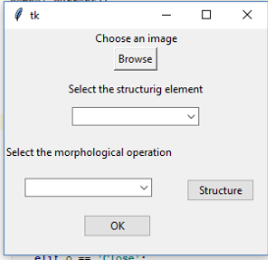

Out of the two option menu widgets one is used for the structuring elements where a user can click on that and select any one of them.

We have included 3 different structuring elements:

1.CROSS  
2.SQUARE

3.HYBRID

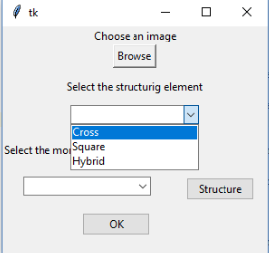

Another option menu widget is created for choosing any one of the morphological operations.

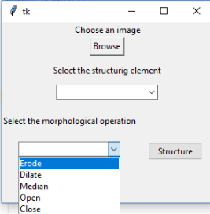

After selecting the desired structuring element and morphological operation the output will be displayed.